RPSRview
The website will focus on functionality, which is why it will use a minimal, table-based UI to display the records. This makes the system compatible with the most browsers and user groups.

Edit list view

By clicking the 'Edit list' button on the other pages the user will be able to change the attributes of each reserve as well as select and delete entries.

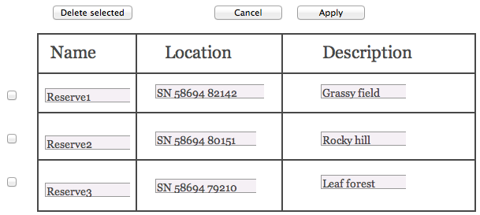

Reserve view

This is the view the user will see when accessing the RPSRview website. It displays the name, location and description of every reserve. By clicking on a reserve's name the user will be taken to the list of plants in that specific reserve.
It is possible to add a reserve to the database by clicking the 'Add reserve' button.

The 'Next page' link and drop-down menu allow the user to navigate the records. This feature is present in the following views, even though not showcased by the images.
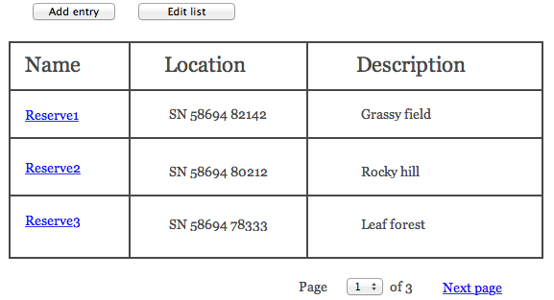
Plant view

The plant view shows every plant recorded (sorted alphabetically) in the selected reserve and the date of their first and last recording. By clicking on a plant's name the user will be taken to the recorder view.
Adding and editing entries in the list functions identically to the reserve view.

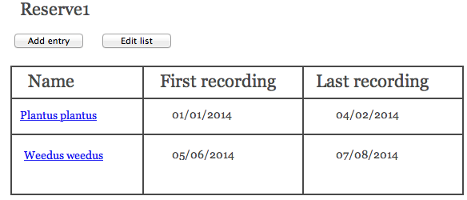

Recorder view

The recorder view displays the names of the users who recorded the selected plant in the reserve, the plant's abundance, photos of the general scene and plant as well as the users' comments The list is sorted reverse chronologically.
Adding and editing entries in the list functions identically to the reserve and plant view.

